# **UnFake News Detection Using NLP**

## **Phase – 3**

We started building our project by loading the dataset, performing text preprocessing, and conducting analysis in Jupyter Notebook.

**Loading the Dataset:**

Downloaded the **train.csv** dataset from the Kaggle

We loaded a train.csv dataset using the **pandas** library.

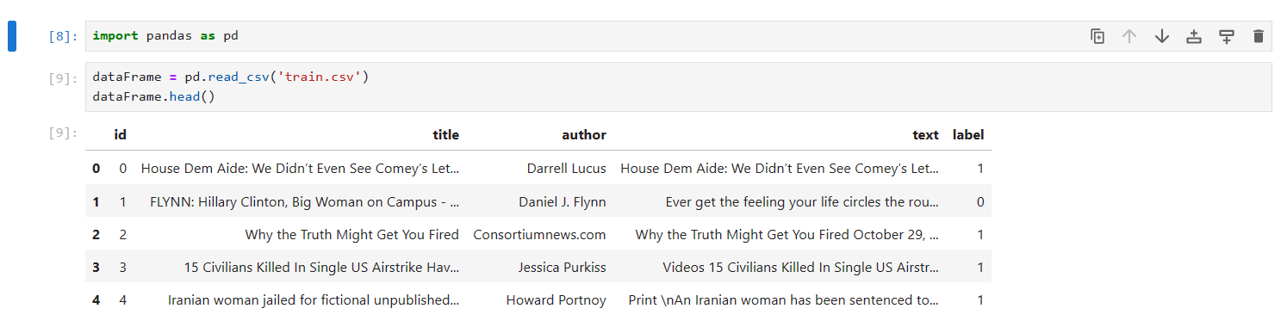

**Text Preprocessing:**

Replacing null values in the dataset with empty string

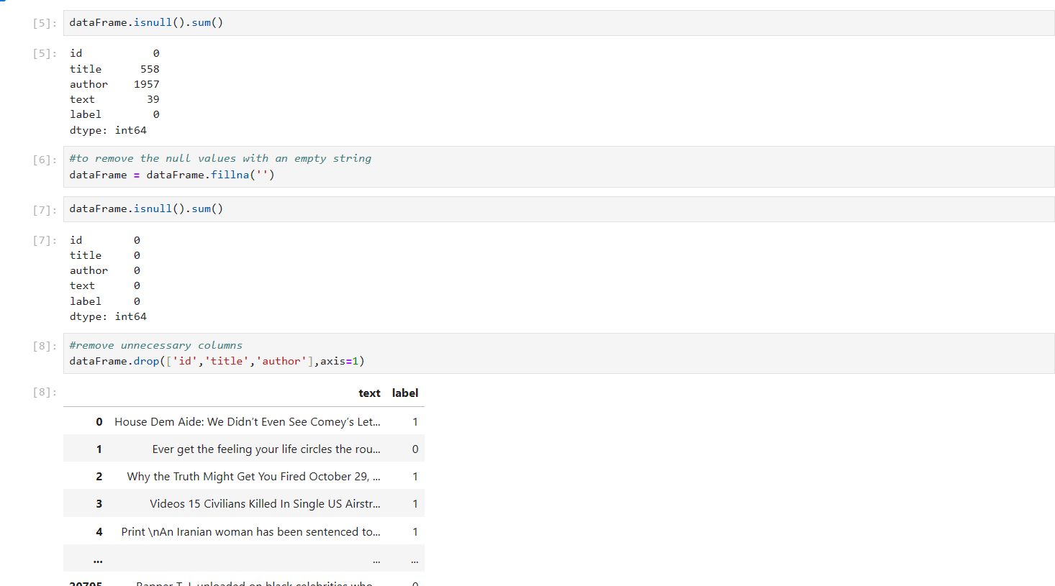

Removing Unnecessary Columns in the dataFrame



Using **Natural Language ToolKit** Library for Text Preprocessing

This code processes the 'text' column in the DataFrame by applying text preprocessing operations like stemming, lowercase conversion, and stopword removal to each text entry in that column.

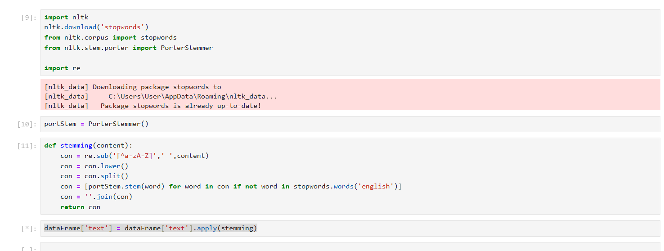

**Members:**

**S.Dhanushiya**

**K.Jelsiya**

**J.Narmatha**

**J.Vijaya**